1. Create a GitLab account if it doesn't exists already.

Account created on Gitlab too.

1. Create a repo GitCommand in your GitLab account

Created repo GitCommand.

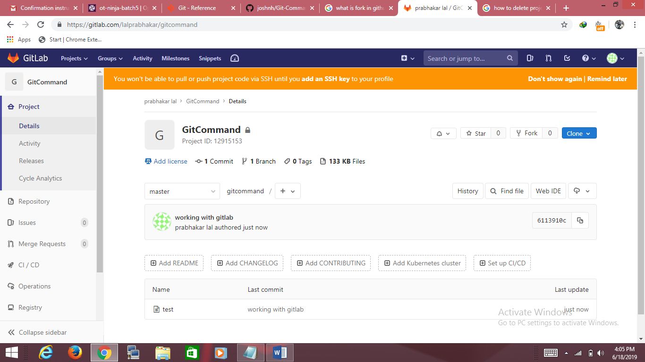

Steps to create new repo on GitLab.

* Click on projects
* On right hand side one option is New Project

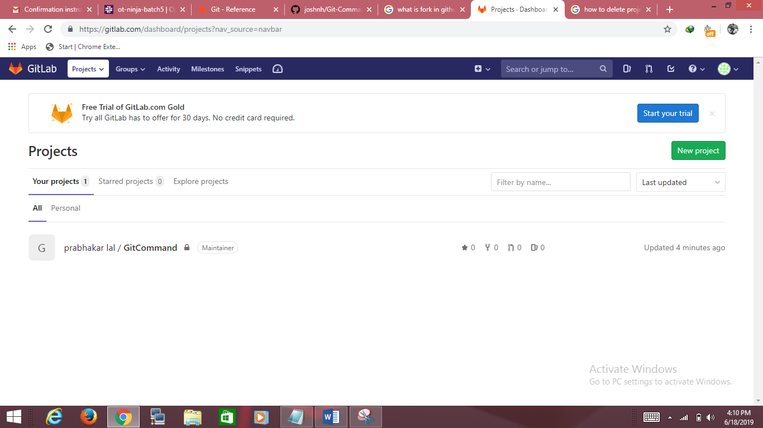

* Click on it, it will create new repo.

1. Delete repo *GitCommand"

Steps to remove project from Gitlab.

* Click on project and type project name
* Click on project which you want to remove
* On left side one panel will open
* Click on setting >>General>>Advance
* Expand the advance section
* Click on option Remove Project
* It will ask for confirmation , provide confirmation on it.

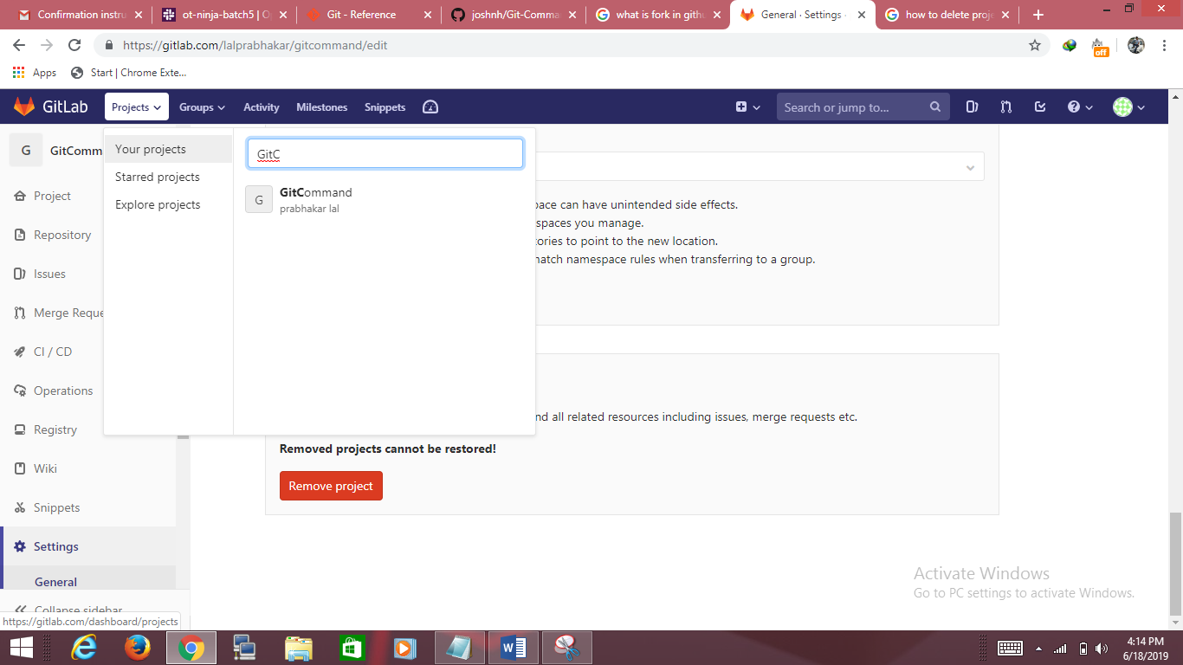

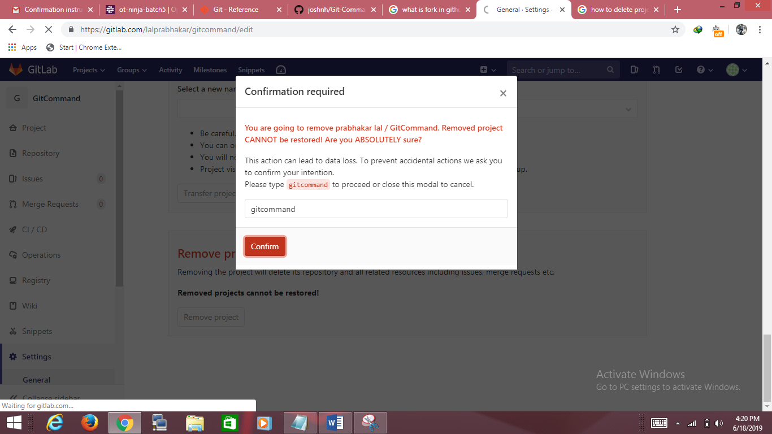

1. Fork https://github.com/joshnh/Git-Commands in your GitLab account with the name GitCommand

Steps to fork(copy).

* Click on create new project

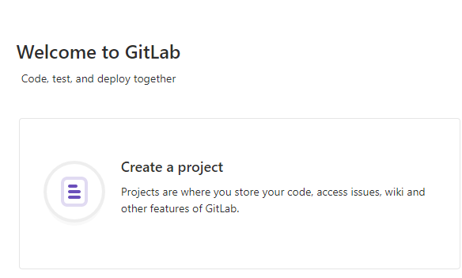

* Click on Import project

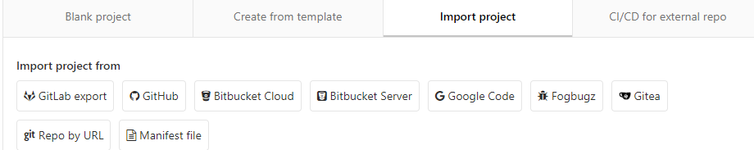

* Click on git repo url

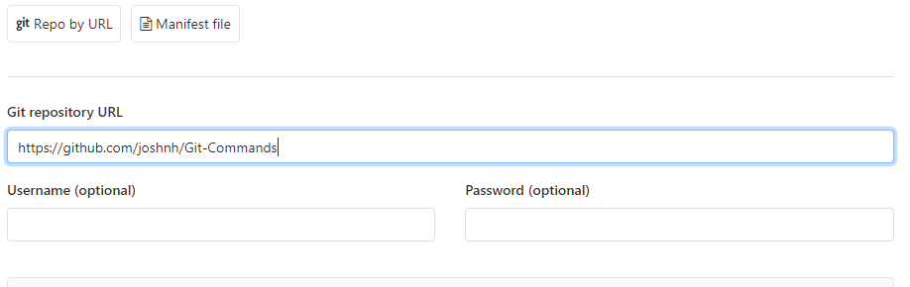

Fill the details as it is free so no Username and password is required.

After fork:-

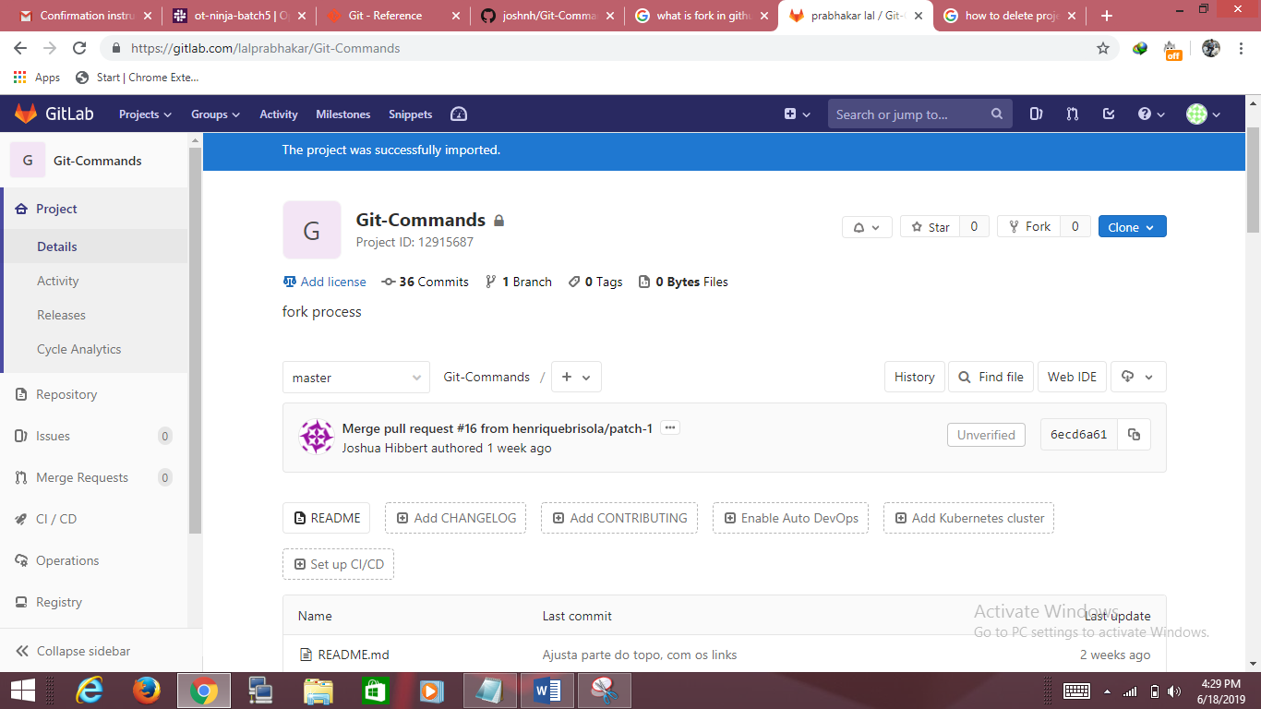

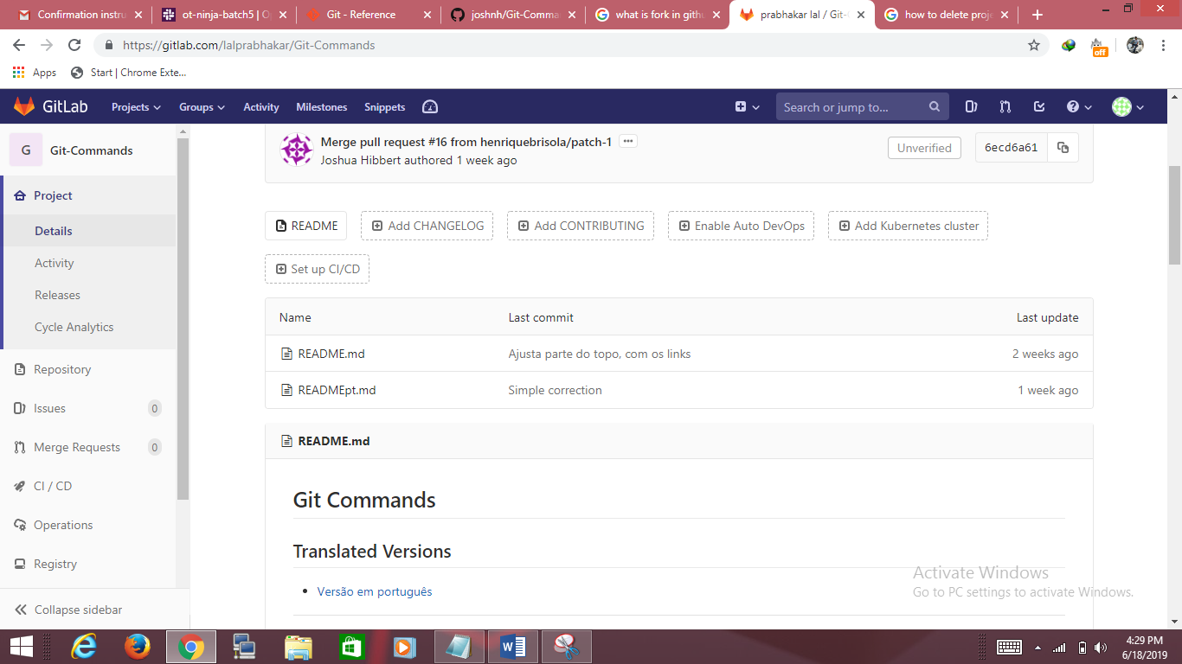

1. Clone GitCommand repo using http protocol

To clone the code from git we use command git clone url

**git clone** [**https://gitlab.com/lalprabhakar/Git-Commands.git**](https://gitlab.com/lalprabhakar/Git-Commands.git)

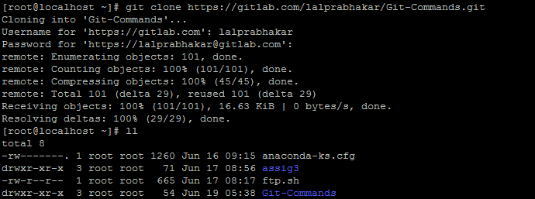

1. Delete the cloned code

Removing the code from gitlab and committing it

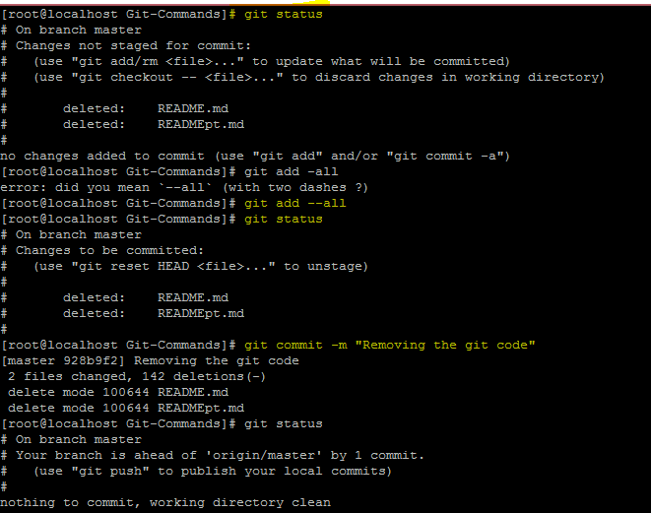

After removing the code and pushing it repo of Git-Command become empty.

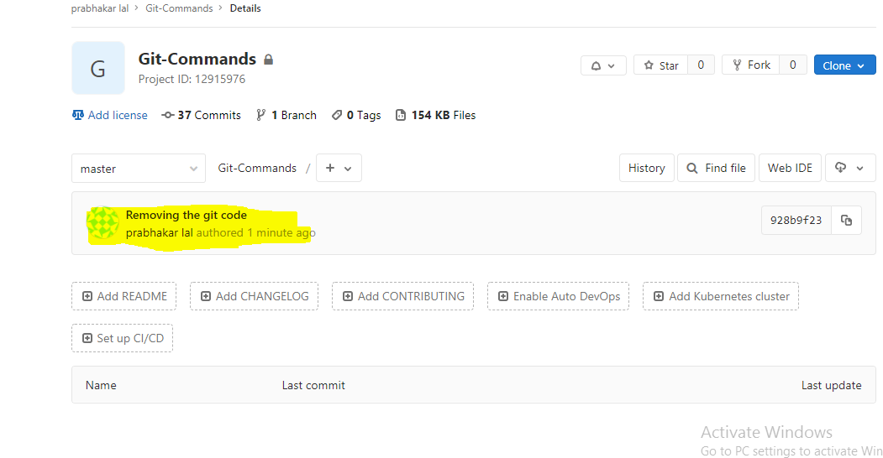

1. Clone GitCommand repo using git protocol at ~/ninja & Create a folder ninja & Create a file README.md in ninja folder & Make your changes available to GitCommand remote repo

While working with http protocol it was asking for username and password for clone and push.

